MORE QUERIES INSURANCE DATABASE

**Question**

(Week 2)

- PERSON (driver_id: String, name: String, address: String)

- CAR (reg_num: String, model: String, year: int)

- ACCIDENT (report_num: int, accident_date: date, location: String)

- OWNS (driver_id: String, reg_num: String)

- PARTICIPATED (driver_id: String,reg_num: String, report_num: int, damage_amount:

int)

- Create the above tables by properly specifying the primary keys and the foreign keys as done in “week 1 programs” and

Enter at least five tuples for each relation

- Display the entire CAR relation in the ascending order of manufacturing year.

- Find the number of accidents in which cars belonging to a specific model (example

“Lancer”) were involved.

- Find the total number of people who owned cars that involved in accidents in 2008.

- List the entire participated relation in the descending order of damage amount. Find the average damage amount.

- list the name of driver whose damage is greater than the average damage amount

-find maximum damage amount

**Schema Diagram**

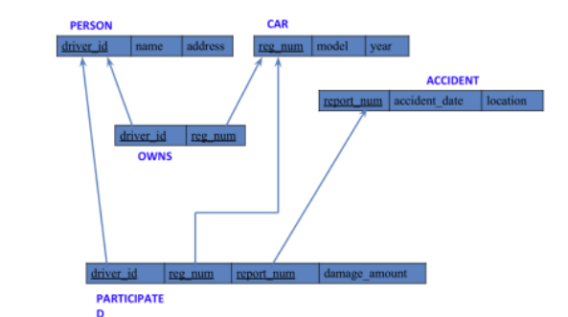

**Create database**

create database insurance1;

use insurance1;

**Create table**

create table person1 (

driver_idvarchar(10),

name varchar(20),

address varchar(30),

primary key(driver_id)

);

create table accident1 (

report_num int,

accident_date date,

location varchar(20),

primary key(report_num)

);

create table car1 (

reg_numvarchar(10),

model varchar(10),

year int,

primary key(reg_num)

);

create table participated1 (

driver_idvarchar(10),

reg_numvarchar(10),

report_num int,

damage_amount int,

primary key(driver_id, reg_num, report_num),

foreign key(driver_id) references person1(driver_id),

foreign key(reg_num) references car1(reg_num),

foreign key(report_num) references accident1(report_num)

);

create table owns1 (

driver_idvarchar(10),

reg_numvarchar(10),

primary key(driver_id, reg_num),

foreign key(driver_id) references person1(driver_id),

foreign key(reg_num) references car1(reg_num)

);

**Structure of the table**

DESC person1;

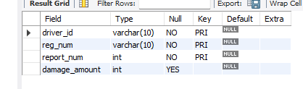

DESC accident1;

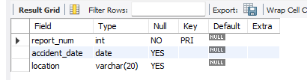

DESC car1;

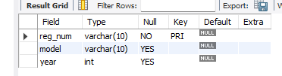

DESC participated1;

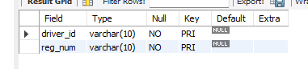

DESC owns1;

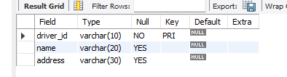

**Inserting Values to the table**

insert into person1 values ('A01','RICHARD','SRINIVAS NAGAR');

insert into person1 values ('A02','PRADEED','RAJAJI NAGAR');

insert into person1 values ('A03','SMITH','ASHOK NAGAR');

insert into person1 values ('A04','VENU','NR COLONY');

insert into person1 values ('A05','JHON','HANUMANTH NAGAR');

select * from person1;

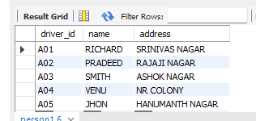

insert into accident1 values(11,'2003-01-01','mysore road');

insert into accident1 values(12,'2004-02-02','south end circle');

insert into accident1 values(13,'2003-01-21','bull temple road');

insert into accident1 values(14,'2008-02-17','mysore road');

insert into accident1 values(15,'2004-03-05','kanakpura road');

select * from accident1;

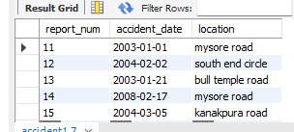

insert into car values(“KA052250”,”Indica”, “1990”);

insert into car values(“KA031181”,”Lancer”, “1957”);

insert into car values(“KA095477”,”Toyota”, “1998”);

insert into car values(“KA053408”,’Honda’, ‘2008’);

insert into car values(“KA041702”,”Audi”,”2005”);

select * from car;

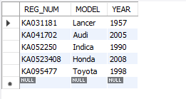

insert into owns1 values('A01','KA052250');

insert into owns1 values('A02','KA053408');

insert into owns1 values('A03','KA031181');

insert into owns1 values('A04','KA041702');

insert into owns1 values('A05','KA095477');

select * from owns1;

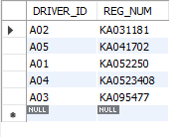

insert into participated1 values('A01','KA052250',11,10000);

insert into participated1 values('A02','KA053408',12,50000);

insert into participated1 values('A03','KA031181',13,25000);

insert into participated1 values('A04','KA041702',14,3000);

insert into participated1 values('A05','KA095477',15,5000);

select * from participated1;

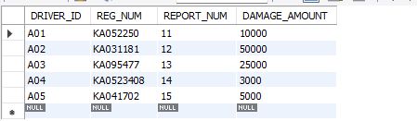

**Queries**

1).Display the entire CAR relation in the ascending order of manufacturing year.

select * from car order by year asc;

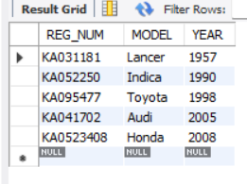

2).Find the number of accidents in which cars belonging to a specific model (example “Lancer”) were

involved.

select count(report_num) CNT from car c,participated p where c.reg_num=p.reg_num and

model=”Lancer”);

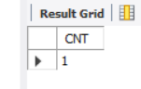

3).Find the total number of people who owned cars that involved in accidents in 2008.

select count(distinct driverid) CNT from participated a, accident b where a.reportno=

b.reportno and b.adate like ‘%08’;

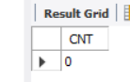

4).List the entire participated relation in the descending order of damage amount. Find the average damage amount.

select * from PARTICIPATED order by damage_amount desc;

select avg(damage_amount) from PARTICIPATED;

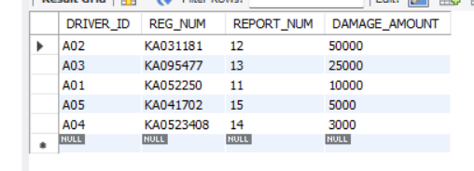

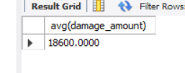

5).List the name of drivers whose damage is greater than the average damage amount.

Select name from PERSON A, PARTICIPATED B WHERE A.driver_id = B.driver_id AND

damage_amount > (SELECT AVG(damage_amount) FROM PARTICIPATED);

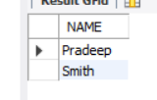

6).Find maximum damage amount

select max(damage_amount) from PARTICIPATED;

